Chapter 6, Solution 61.

(a)
Using current division,

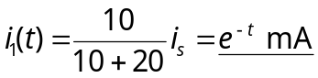

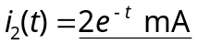

(b) 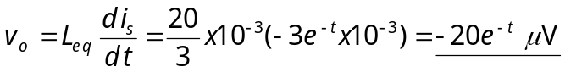

(c ) 